Deep Learning Task 4 Documentation

Part 1
Our dataset is a subset of the PETS dataset, and our task is to classify weather a given image is a photo of a Beagle or a Boxer. We first download the data and then filter out the two breeds. The size of this dataset is 400 (about 200 for each breed), test size is 0.8.
For starters, we have chosen our network to look like the one demonstrated in the lecture- a deep network with several layers- to see if it's a good starting point. The parameters are the following :
self.cnn1 = nn.Conv2d(in_channels=3, out_channels=10, kernel_size=3, stride=1)
self.cnn2 = nn.Conv2d(in_channels=10, out_channels=20, kernel_size=5, stride=2)
self.cnn3 = nn.Conv2d(in_channels=20, out_channels=400, kernel_size=5, stride=2)
self.adaptive_pool = nn.AdaptiveAvgPool2d((1, 1))
self.fc1 = nn.Linear(400, 1)
The network takes the image (represented as 3 filters, RGB) and transforms it into 10 feature maps. Then into 20 and then 400 channels- shrinking the image as we progress via larger kernels and stride sizes. Eventually, we get the image represented as an input of size (400,1) which we then send into a neuron to get a probability. The activation function in the hidden layers is relu and at the output layer is sigmoid.
We'll be testing and comparing SGD, mini batch and batch GD and ADAM optimization algorithms with momentum of 0.9 and learning rate of 0.05.
Test1: running 10 epochs took about 8m, the test accuracy rate was concerningly low - about 45% - Even though the error rate itself started relatively low (about 0.72 and ended around 0.68). Our guess is that the model exhibits a classic case of overfitting- The error on the train set is small but when approaching new data the model simply doesn’t generalize well and gets low accuracy. Since the error fluctuates during training I guess we should decrease the number of epochs and the learning rate.
Test2: running 5 epochs with learning rate of 0.005 yields a 50% accuracy rate on the test set with similar results to the previous test.
We ran additional tests with 5 epochs and varying learning rates (from 0.005 to even 1) and the accuracy rate is still low and there were even cases where the model predicted only one breed of dogs and not a single prediction of the other breed, so we think about trying the ADAM optimization algorithm before switching to a shallower network.
Test3: running 5 epochs with the ADAM optimization algorithm with learning rate of 0.001,0.01 and even 0.1 – we still get bad overfitted results with cases where the model has predicted a single breed for each image.
After seeing ample evidence that suggest overfitting- we tried a more shallow network.
Now, we are trying a shallow network that has one input layer, one pooling layer and then a single output neuron:
self.cnn1 = nn.Conv2d(in_channels=3, out_channels=16, kernel_size=3, padding=1)
self.pool1 = nn.MaxPool2d(kernel_size=2, stride=2)
self.fc1 = nn.Linear(16 * 112 * 112, 1)
We are now using several other tools such as the pocket algorithm during the optimization process- we save the weights where the loss was minimal. We also now run 15 epochs with the GD algorithm with momentum of 0.9
Test1: We tried to use first the SGD with learning rate of 0.001 and we got pretty bad results – the loss fluctuated between 0 and 100 and at the end the confusion matrix showed it predicted constantly only one breed.
Test2:We changed to mini batch GD with batch size of 64 and the results were the best so far – 75% accuracy rate on the test set. We also tried with learning rate of 0.01 but the loss diverged so we stopped it halfway through.
Test3: changed optimization algorithm to ADAM with the same learning rate of 0.001. The model didn't constantly predict a single breed, but the accuracy itself isn’t good enough – about 55% accuracy.
Regarding Normalization methods- we haven't used anything serious up until now, so we normalized the data to range [-1,1] and the results are slightly better – about 60/80 correct predictions.
We also added batch normalization in addition, and while the loss dropped much more sharply- the accuracy rate hasn’t really changed and is still around 60/80 correct predictions.
After adding BN to our best performing architecture, we reduced the number of epochs to 10 and changed the learning rate to 0.0001 (same momentum of 0.9 using the 64 batch GD algorithm), we get to see that we can preserve the highest accuracy rate we have managed to achieve (60/80) using less iterations. We also increased the number of epochs to 12 to try and get the last squeeze out of the algorithm.
Training Stability – during the last run, the Losses were pretty stable compared to without BN methods or higher LR. The Loss is steadily declining from 0.70 to 0.17. In comparison, without BN the Loss is fluctuating up and down and at the end of the training is still not close to being low enough (a run of the model without BN resulted in final loss of 0.55 while starting in 0.67, even though surprisingly the results were also not bad accuracy-wise).
Convergence Speed – We compared between the networks without BN and the one with (rest of the parameters were the same). We tried to find how many epochs are needed for each network to reach a loss of 0.2: The network with the BN reached that loss in about 8 epochs and retained its good results, while for the network without BN it didn't even each it in over 30 epochs.
Validation Performance – We observed that both networks had around the same validation accuracy with and without BN while sharing the rest of the parameters.
As for the next step, we'll be adding one regularization method to the model and seeing how it affects on the results.
Data Augmentation: We added 2 modifiers for the images in the dataset. We then ran the code with and without the augmentation and the results were a bit better in accuracy- the augmented data got 58/80 while the normal data got 52/80.
Weight Decay: The results with this method weren’t too different from the original model- averaging about 51/60 accuracy rate while the model without the regularization method scored about the same. The initial weight value selected for the parameter was 0.0001 .
Dropout: using dropout rate of 50%- we landed on a pretty nice result of 57/80 accuracy rate. We also tried 35% and got 52/80 accuracy.
We also tried using all 3 methods together to see If they perhaps enhance each other- and the results were pretty good as well with 56/80 accuracy on the first run and 55/80 on the second run- considering the results were pretty good in both run using all 3 regularization method then we have decided to keep them all in the model as is (dropout rate is 50%).
We then also tested the model on the train set and got 100% accuracy while the test accuracy was no more than 60/80- it is a clear sign of overfitting and our guess is that the network is yet still too big and can easily overfit, so we're trying a smaller network. The new network is a bit smaller than the previous one :
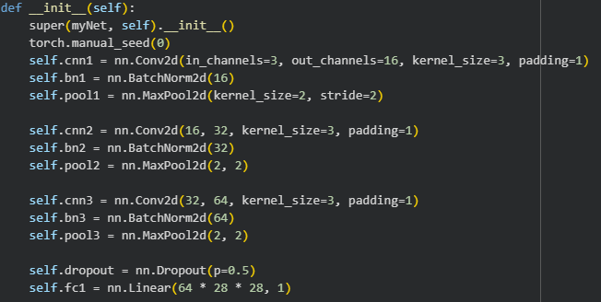
It still incorporates the regularization methods discussed previously but it shows the accuracy on both the test and train. This network produces a 65% test accuracy and 95% train accuracy. We don't try too much to reduce the gap between the accuracies since we know out dataset is pretty small and overfitting is natural.
As for the next part, we have done some modifications for the code to allow transfer learning: we modified the network to accommodate 10 classes, removed the sigmoid activation at the end of the forward pass, changed the loss criterion from BCE to regular CE,and also some more technical changes to allow the network to classify 10 classes correctly. Since the CIFAR dataset is pretty huge- we have selected a random 10% of the dataset (which was still pretty cpu intensive- the training took about 70m) and trained the network on the data. After the training part was done we saved the trained weights as a file to reload later.
Afterwards, we modified the network back to its original form, loaded the weights we had learned from the CIFAR dataset and ran the training on our original test dataset. The results were significantly better for the test set- a whopping 95% accuracy rate on the beagle/boxer test set after training on the train set with the CIFAR weights as initial weights, compared to no more than 73% accuracy rate with previous method that included normalization and several regularization methods.
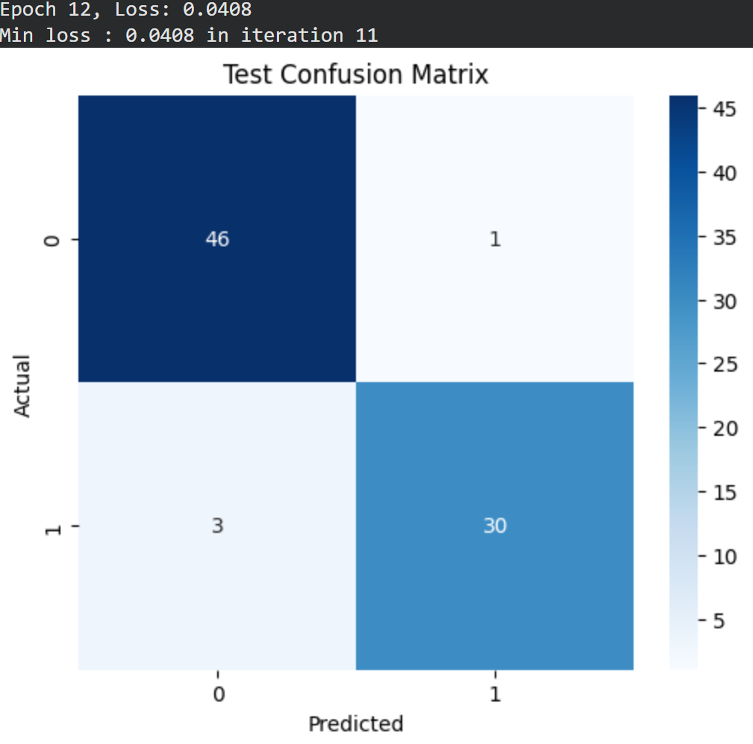
Regarding convergence speed – the loss during the second training phase was very consistent and low throughout the process. The initial loss was about 0.7 and as soon as iteration 6 where we passed the 0.2 threshold and kept on descending consistently towards the minimal loss.
Regarding generalization – the model has trained on the CIFAR data and by that (and the high accuracy on the test set) we can deduce that it has successfully learned important features from the dataset and it used these features to distinguish specific features in our dataset that it wasn’t able to do before. It conclusively proves that training the network for our task while using initial learned weights (the "knowledge" from the CIFAR dataset) was helpful to build upon in order for us to learn and successfully classify our two dog breeds.
As for the next step in the experiment, we'll now import and use the Resnet50 NN that is already pretrained on millions of images across hundreds of categories. Unlike the CIFAR database for which we had to train our network on and then train it again on the train data (we used the CIFAR data to basically give us good initial weights to start the training process with)- this time we will import a professional and ready model that is already trained on millions of images and just fine tune it to our dataset.
After loading the model, we freeze all the weights of the model except for those in the last layer- we want to "unscrew" the last layer with over 1,000 outputs and "screw in" instead a layer that matches our task which is binary classification (which requires only 1 output node). In order to avoid problems with our train implementation which is meant for our model – we created a new train method that now gets the model to train on as well. We trained the model on our train dataset and after about 20m of training the results on the test dataset came: 95% accuracy rate on the test dataset with consistent loss descent. In our case, the loss itself wasn't lowered to under 0.62 even though in previous models we trained on the data the loss went down as far as to 0.04.
As for the freezing part of the experiment- we have decided to freeze the entire model except the last layer since training a model as big as that might be very costly cpu wise. In addition, since the model is very big as it is, it might memorize the data and overfit easily so we just let the model stay as it was - with all the knowledge and information it has learned over its training process – and just train the last layer of the network to fit for out specific simple task.
We tried different learning rates and even disabling some regularization methods, but we concluded that these changes in the network weren’t significant and didn't really improve convergence speed or accuracy rate.
Comparison between our initial, best working, from scratch network and the pretrained network using transfer learning :
Performance : Some might say the most prominent and maybe important metric. While our original model scored at best a score of 65% with normalization and all the regularization methods- both the models (the one that used the CIFAR database as a training dataset and the Resnet50 net) showed much more success in accuracy with 95% accuracy rate.
Training time : time wise the computations were a bit slow. The training time for our original simple model was no more than 5m- while training the CIFAR model took more than an hour and the Resnet50 model training took about 20m. It's understandable since our model had to train only on its 320 images while the CIFAR one had to train on 10% of the data which is 5000 images. Same goes for the Resnet network- the network itself is pretty big as it is so even with frozen weights it took more time to train.
Stability : Our original network's stability was very much dependent on several parameters. We had runs where the loss fluctuated and behaved inconsistently throughout training sessions and other runs where the loss was more stable. On the other hand, both the CIFAR and Resnet50 models demonstrated very stable loss decreases- In both training processes the loss decreased steadily and barely fluctuated.
The loss plot over iterations using the Resnet50 model is as following :
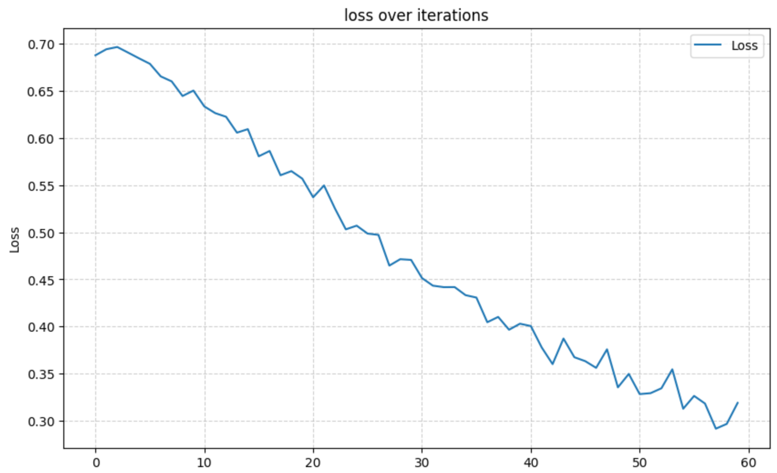
As we can see, the loss fluctuates a bit but as an overall trend goes down steadily.
The loss curve on the original model (with the optimal results we found at the beginning):
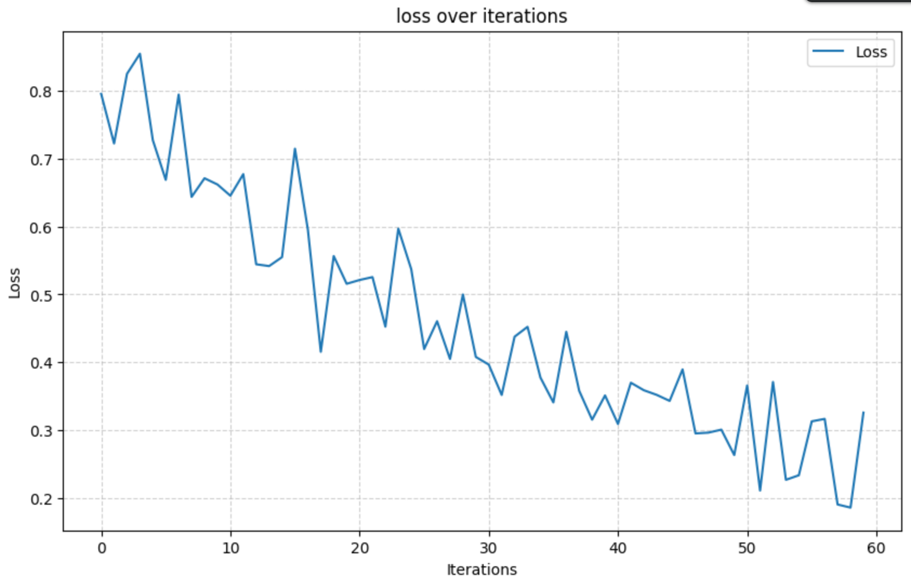

As we can clearly see, the curve fluctuates much more than the loss in the previous model. It can also be seen that the old model descends a bit slower than the Resnet model- meaning it reaches the minimal point faster than the original model.
The losses for each epoch in the original model :
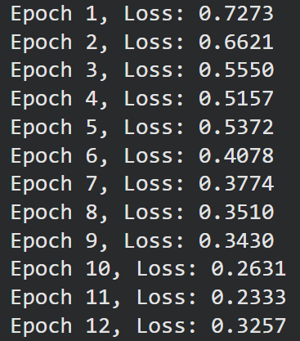
The model's losses over the iterations have some small fluctuations but they descent steadily- reaching a minimum value of about 0.3 with the accuracy rate of about 65%.
Regarding the models themselves, we can clearly see that using the trained weights of the CIFAR model (using transfer learning) has given our model vital information about shapes and characteristics that may be found in dog breeds - and more specifically – Beagle and Boxer breeds. It appears that the model has gained knowledge from the transfer training that helped it recognize key features that help it differentiate between images of Boxers and Beagles.
We can gain more information from the confusion matrices as well ; We can see that even though the division of the test images was almost the same (the were a few more images from one breeds than the other)- the results showed in either model that it had some knowledge on the images it was tasked to classify- meaning the results were indeed a bit poor for the original model but definitely not as bad as a random classification. We can also see that when using the more advanced tools of transfer learning we got much better results in the confusion matrix- with less than 5 mistakes overall.
In conclusion- we can clearly see that the relatively simple model we have created did score mediocre results even when it had used normalization and regularization methods, while using the learned characteristics from a different and more robust model have significantly increased the performance and accuracy of the classifying model.
REFLECTION
Choosing the initial architecture was indeed a big hurdle that we tackled early in the project- We first decided to select a more potent and powerful network rather than a shallow one, because that way we can see if there's overfitting then we would probably need to switch to a shallower network. So as documented, we selected an arbitrary initial deep network that was used in one of the presentations in a lecture- We ran tests and saw poor results that suggested overfitting so we switched to a shallower networks. After we came to the conclusion that a too shallow network doesn’t work but something in the middle- we added more layers for our CNN such as the MaxPool layers to process the data further between layer and made sure the size of the data between each layer shrank (it was still relatively big, but much smaller than the initial size it was in the initial architecture).
We then decided to added the regularization methods that turned out to work well together rather than a subset of them. We also normalized the data pretty early on and got better results.
Regarding optimization methods- we have tested with several algorithms (ADAM,BGD,SGD,MBGD) with various learning rates, momentums and epochs (epochs we changed last, because we were under the assumption that a good model with good learning rates and momentum will achieve great results quickly and in a reasonable number of iterations. Not to mention that after 10-12 iterations the results were great so we didn’t want to try more epochs to not overfit).
Transfer learning greatly helped us when we felt like the model wasn’t capable of learning and differentiating based on the size of train data it saw. We acknowledged that to train a model on 300 images is not ideal and that the results may be limited, so using this technique which is basically to train an experienced model for our task really showed us the power of a good model and how big datasets of whatever can help even our very specific task.
In conclusion, with more data we might have been able to experiment more with the parameters for the model and have more nuances about the accuracy we had and wanted to have. With more time it might have been possible to train on a more robust dataset and perhaps use the techniques we used with CIFAR and Resnet50 models (the training processes for both were relatively long- the initial CIFAR training took 1h+ and Resnet50 train took about 25m) So we could have definitely done better time-wise.

